Shabbos Stories for
Parshas mikeitz 5782
Volume 13A, Issue 15 - 30 Kislev/December 4, 2021
Printed L’illuy nishmas Nechama bas R’ Noach, a”h

For a free subscription, please forward your request to keren18@juno.com
Past stories can be found on the website ShabbosStories.com

A Child’s Hospitality
By Rabbi Dovid Goldwasser

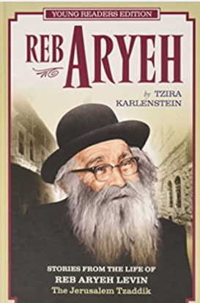

The great R’ Aryeh Levine used to visit the hospitals and wish every person a refuah shleimah. Once, when he came to the Bikur Cholim Hospital, he found that one of the staff members, a well-known tzaddik, R’ Yosef, was very sick. R’ Aryeh sat down near him and tried to speak to him. Suddenly the patient lost consciousness. R’ Aryeh called the doctor and staff to revive the patient. They worked for over two hours until R’ Yosef was stabilized.

Asked R. Yoef “What Happened”
R’ Aryeh, who had remained nearby the entire time, asked R’ Yosef what had happened.
The tzaddik recounted how he had been brought before the Heavenly Court. Hundreds and thousands of angels dressed in white appeared before the Court and said that they had been created from the different mitzvos the tzaddik had done. Afterwards, angels who had been created from his aveiros came in, dressed in black. One said the tzaddik hadn’t prayed properly, one said he had eaten something that was prohibited when he was a child, and other such transgressions were cited.
When the aveiros for which he hadn’t done teshuvah were tallied, his merits and transgressions were equal. As his verdict was debated, one of the prominent rabbis in Yerushalayim who had been on the vaad of the Bikur Cholim/Chevra Kadisha and had passed away some years ago, entered.

All the Judges Rose in His Honor
Upon his entrance, all the judges rose in his honor, and asked why he had come. He explained that he had heard that they were judging R’ Yosef, whom he knew very well, because R’ Yosef had been one of the people on the staff when he himself had been head of the committee. He now wanted to testify on behalf of R’ Yosef that he was a very truthful and honest person.
It was decided that since his rov had spoken so highly of him they would allow him to go back to the world to correct his wrongdoings.

Wandering in Search
Of a Way Back Home
R’ Yosef wandered over mountains and through valleys trying to find his way back to the world when he heard a voice call out to him, “R’ Yosef!” He saw a man sitting on one of the mountains; the man asked R’ Yosef if he remembered him.
R’ Yosef responded that he didn’t remember him.
The man reminded R’ Yosef that he had lived in the city where R’ Yosef lived as a young boy. Every Shabbos, the people of the town would invite guests, but no one wanted to invite this man because they thought that he ate too much. He therefore had nowhere to eat.

Pleaded with His Father to Bring
The Man Home for a Shabbos Meal
Once, R’ Yosef and his father were the last two people to leave shul, and R’ Yosef pleaded with his father to bring the man home. At first, his father was reluctant, but finally, he agreed and that Shabbos the man ate at their home. When he left on Motzoei Shabbos, the man had told R’ Yosef that one day he would repay him for his kindness. But they never met again, and the man had been unable to repay him.
Now he sees R’ Yosef wandering, and he wanted to know what he could do for him.
R’ Yosef explained that he was trying to get back to this world and was unable to find the way.
The man showed him the way, R’ Yosef concluded, and here he was, back in his hospital bed.

Reprinted from the Parshat Chaya Sara 5782 website edition of The Jewish Press.

Story #1246
The Queen of Early
New York City Jewry
From the desk of Yerachmiel Tilles
Editor@ascentofsafed.com

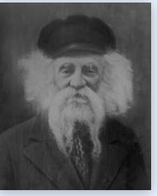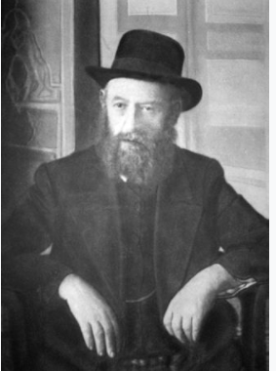
The Rogatchover Gaon The Rebbe Reshab

She was a familiar figure in the alleyways of the Batei Hungarim neighborhood in the Meah Shaarim section of Jerusalem. An aged widow who lived alone for many years, known for her righteousness. Every morning she would rise early in order to open the doors of the Chasidic shul (synagogue) where she would davven (pray) the dawn morning service from her place in the women's section. She would be careful to also pray the afternoon and evening services.
Her acts of kindness were known to all, though her amazing personal story was known to only a few.
Her name was Devorah-Miriam Queen. She was born in the year 5633 (1873 c.e.) in of Dvinsk, Latvia. She was orphaned from her father as a young child and her mother was left alone with her small children.
The mother's brother-in-law, her late husband's brother, took them into his house and took care of all their needs.

Brought Up in an Atmosphere of Piety
Devorah Miriam was brought up in an atmosphere of piety and positive habits. When she grew up she wanted to marry a Torah scholar. Her uncle though wanted her to marry his son, so Devorah Miriam's dream stayed hidden and in the year 5654 (1893 C.E.) she married her cousin.
The years went by. The couple maintained a religious household, but their childlessness caused them great worry. After ten years of marriage and disappointments the family started thinking that maybe Devorah Miriam and her husband should divorce.
After prolonged deliberations the two decided to present their dilemma for consideration to the Rogatchover Gaon (genius), Rabbi Yosef Rosen,who was the chief rabbi of the Chasidic residents of Dvinsk [1] where they lived, and was considered one of the greatest Torah scholars of the century,
He listened to their story and replied: "If your question is if you are allowed to divorce, the answer is yes; but whether you should do so is not a question for a Rabbi but for a Rebbe."

Travels to See the Rebbe Reshab
Devorah Miriam's family belonged to chasidut Chabad. So, from the house of the Gaon the couple traveled to the town of Lubavitch, to Rabbi Shalom-Dovber Shneersohn, the Rebbe Rashab. They related their troubles to the Rebbe's gabbai (attendant).
They asked him to arrange a yechidut (private meeting) for them with the Rebbe. To their regret the gabbai couldn't help them, as there was already a long line of people requesting audience with the Rebbe.
The couple's disappointment and sorrow was obvious on their faces. Moved, the gabbai advised them to wait next to the Rebbe's door. "When the Rebbe will come out of his room he will see you and will listen to your trouble."
Indeed, when the Rebbe left his room he noticed them waiting outside his office and invited them to enter. Before they even had a change to say a word, the Rebbe said "The advice you were given to divorce is incorrect. My advice is that you fulfill the saying of our Sages 'He who changes his place changes his mazal (fortune) for good and blessing.' Go to America and there you will have children and many blessings."

They left the Rebbe's presence in great emotional turmoil and amazement, because of the Divine Spirit that the Rebbe revealed and because of the unexpected advice he gave them. America in those days was a spiritual desert, almost without the availability of a suitable Jewish life.

Started Arrangements
For Their Immigration
But they followed the instruction of the Rebbe and the next day they started the arrangements for their immigration. The news of their intended departure spread quickly throughout Dvinsk, for a trip to America was not a usual thing in those days.
Equipped with the blessings of the Rogatchover Gaon and the Lubavitcher Rebbe, the husband and wife set out on their travels. The next year they were in America, trying to get used to the strange new reality. Both made the decision not to be drawn after American culture and to keep their Jewish values come what may.

Became Mainstays of
Jewish Life in New York
Very soon they became the mainstays of the establishment of Jewish life and the world of Torah in New York. Among other things they founded a Talmud Torah (Torah exclusive elementary school) so that the children would be brought up on Torah values alone. In time this became the famous yeshiva "Torah VeDa'as". They also instituted kosher slaughter and other religious institutions.

The Couple’s Eight Children
All Merited Long Lives
Indeed, the blessing of the Rebbe Rashab was fulfilled. The couple had eight children and all merited long lives. They lived in Williamsburg in Brooklyn and davvened in the Tzemach Tzedek shul. When for various reasons this shul was sold, the money was transferred to the Chabad shul in Jerusalem of the same name.
The couple merited that their descendants remained Jews faithful to the ways of their ancestors. Devorah Miriam was widowed in the year 5687 (1926 c.e.). She remained in the USA until reaching the age of eighty when she decided to move to Israel. Her firm decision and strong character eased the difficulties of the change. She went to live in Jerusalem, the Holy City.

Continued a Life of Prayer
And Acts of Kindness
Devorah Miriam merited great longevity and all the while didn't cease from prayer and acts of kindness. Once, one of her sons came to visit her, and brought her an expensive present, an electric refrigerator, something that was a rarity at that time.
When next year he visited her again he was taken aback to find the refrigerator gone. "I gave it to hachnasat Kala (assistance to a new bride)," she explained. Her son felt compelled to buy her a new one. But this time he made a condition: she is not allowed to give it away; the refrigerator stays in his possession and he is just allowing her to use it!

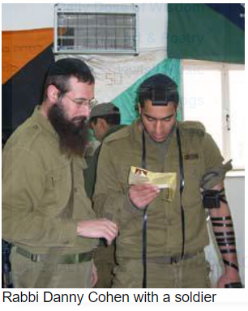
This amazing woman passed away in 5744 (1984 C.E..) at the age of 111. Today, her great-grand child, Rabbi Daniel Cohen, is the highly successful shaliach (emissary) of Chabad in Hebron. [2]
A few years ago, Rabbi Cohen initiated the restoration of Beit Romanov that the Rebbe Rashab had bought and turned it into a lighthouse of the spreading of Chasidic values. He saw this as a closing of a circle “the great-grandchild who was born from the blessing of the Rebbe Rashab merited to renew his asset in the city of our patriarchs, Hebron.
~~~~~~~~~~~
Source: Translated from Sichat Hashavua #1577 by C.R. Benami, long-time editorial assistant for AscentOfSafed.com. Edited and supplemented by R. Yerachmiel Tilles.
Connection “this week’s Torah reading, 1st verse (Gen. 23:1): The life of Sarah was 127 years. Rashi: All the years she was equally good.
Biographical notes: Rabbi Yosef Rosen, known as the Rogatchover Gaon [of blessed memory: 5618 - 11 Adar, 5696 (1858 - March 1936 C.E.)], was an unparalleled genius, whose in-depth understanding of all Talmudic literature left the greatest of scholars awestruck. He authored tens of thousands of responsa on the Talmud and Jewish law, of which many have been compiled in the numerous volumes of Tzafnat Paneach. He served for decades as the chief rabbi of the chasidic congregations of the Latvian city of Dvinsk (Daugavpils).

Rabbi Sholom-Dovber Schneersohn [of blessed memory: 20 Cheshvan 5621/2 Nissan 5680 (Oct. 1860 - April 1920)], known as the Rebbe Reshab, was the fifth Rebbe of the Lubavitcher dynasty. He is the author of hundreds of major tracts in the exposition of Chasidic thought. In 1915, after 102 years of four Chabad rebbes living in Lubavitch, he
transferred the center of the movement to Rostov-on-the-Don.

[1]The chief rabbi of the non-chasidim was also a renowned Torah scholar, Rabbi Meir Simcha ha-Kohen, the author of Ohr Samayach and Meshech Chochma.
[2] https://www.chabadhebron.com/

Reprinted from the Parshat Lech Lecha 5782 email of KabbalaOnline.org, a project of Ascent of Safed.

Reb Chaim Ozer’s Gustman
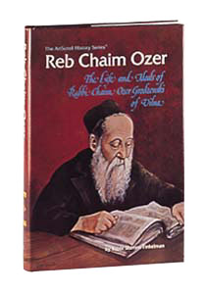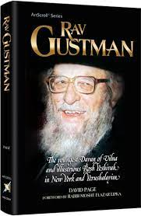

R’ Yisrael Zev Gustman (1908-1991) became a dayan on the prestigious Vilna Beis Din when he was in his early 20’s. He soon became a “yeled sha’ashuim” (favorite child) to R’ Chaim Ozer Grodzinski (1863-1940), and their bond was so close that he was known as “Reb Chaim Ozer’s Gustman.”
R’ Chaim Ozer entrusted him with ever-increasing responsibility. R’ Gustman, still in his early 20’s, was answering she’eilos sent to R’ Chaim Ozer from such Torah luminaries as R’ Menachem Ziemba, R’ Chaim Heller, R’ Yechezkel Abramsky, the Satmar Rebbe, the Gerrer Rebbe, and the Tchebiner Rav.
R’ Gustman found it extremely difficult to adhere to the command given by R’ Chaim Ozer, after he became a dayan: “Don’t treat me with excessive respect or I’ll have nothing to do with you.”
R’ Gustman’s awe of R’ Chaim Ozer remained undiminished by the years. Once a question in treifos arose, and R’ Chaim Ozer said, “Let’s see what the Rishonim say about this.” The first place he turned to was a teshuva of the Rashba dealing with the korban Pesach, which mentioned the issue in a brief aside. For every question that arose, R’ Chaim Ozer would cite some ten equally obscure sources in the Rishonim.

A Dayan Must Have to Courage to
Decide the Most Difficult of Questions
R’ Chaim Ozer taught R’ Gustman that a dayan must have the courage to decide even the most difficult questions. Shortly after assuming his duties, an extremely complex question came to R’ Gustman, which he referred to R’ Chaim Ozer. R’ Chaim Ozer sent back a message: If you expect to receive a salary as a rav, you must pasken all she’eilos.
Six years after the Nazis yemach shemo entered Vilna, R’ Gustman, his wife and daughter returned to Vilna, barely alive, having miraculously survived in the forests, in a cave, and in other hiding places, suffering unspeakable horrors. They had escaped death by a hairsbreadth, countless times.
A bullet once grazed R’ Gustman’s scalp! They were among the mere 800 Vilna survivors. R’ Chaim Ozer seemed to have foretold his survival when he told his beloved disciple that he alone of the dayanim of Vilna would escape from the bear of the West (Germany) and the wolf of the East (Russia).

Lessons from a Walk in the Forest
On a walk in the forest prior to the war, R’ Chaim Ozer uncharacteristically pointed out to R’ Gustman various grasses, noting which were edible and which were not – information which proved lifesaving to R’ Gustman and his family when they subsisted on this vegetation during their years hiding in the forest.
R’ Chaim Ozer had also pointed out a cave to R’ Gustman, saying cryptically, “Remember where that cave is.” It was that cave to which R’ Gustman and his family fled when they escaped from Vilna, and in which they remained for a long period of time, often sucking out the moisture from clods of earth to remain alive… Many years later, R’ Gustman would state that his survival had indeed been “decreed” by R’ Chaim Ozer.

Reprinted from the Parshas Chayei Sarah 5782 email of The Weekly Vort.

The Muddy Path to Paradise
By Asharon Baltazar

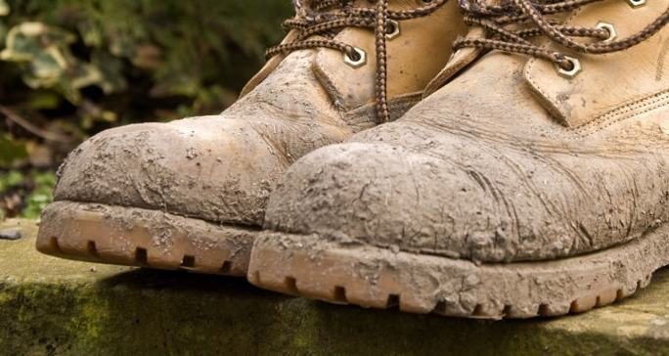

A certain chassidic rebbe had a custom of visiting various Jewish communities, where he would stay in the homes of his wealthy chassidim.
In one of the cities that the rebbe would visit, there lived a wealthy chassid. Although he considered himself a follower of the rebbe and owned a large mansion with many rooms, whenever he heard of the rebbe’s arrival in his city, he made sure that his mansion was locked.
Well aware of his rebbe’s tendency to stay at the homes of the wealthy, where there was ample room to welcome the masses who clamored to consult with him, the chassid would hurriedly leave his mansion, disguising his aversion to hosting as a last-minute business trip. He preferred that his house be left alone.

The Wealthy Chassid is Caught Off Guard
The suddenness of the rebbe’s appearance in his city caught the chassid, along with his wide-open mansion, off guard. Left with no choice, he reluctantly surrendered his house so that it could serve as the rebbe’s accommodation.
A few days later, the rebbe asked the chassid a very frank question: “Tell me the truth, are you not happy with the fact that I am here?”
“Nonsense, Rebbe. You are my most esteemed guest,” replied the chassid earnestly. “I am thrilled to be hosting you and delighted that you chose to stay at my house. The problem I have does not lie with you but rather with the chassidim. You see, when you come, they come. And when they come, along comes the muck from the streets. The very thought of all that grime on my clean floors and furniture just horrifies me. “It was never because of you, G-d forbid. But the idea of the mud has always been off-putting to me.”It was never because of you, G-d forbid. But the idea of the mud has always been off-putting to me.”
Instead of addressing the man’s complaint directly, the rebbe responded with a story:

A Pharmacist who was an Avid Sinner
“There once lived a pharmacist who, as an avid sinner, managed to transgress almost all of the Torah’s prohibitions. After a long life of pleasure, the pharmacist was greeted in heaven by the horde of prosecuting angels that he managed to create throughout his lifetime of sins. Their loud, emphatic accusations and protests challenged the heavens to find a sliver of virtue for his poor soul.
“Suddenly, an angel appeared before the heavenly court and began to tell an account of kindness that transpired in the pharmacist’s youth: It once happened that a man’s wagon, overloaded with merchandise, keeled over in the road. The horse was pinned to the ground and the wagon driver, unable to raise the upended wagon by himself, stood by helplessly as he waited for aid that did not seem to come. “However, continued the angel, the young pharmacist happened to be traveling down the same road. And when the wagon driver’s misfortune met his eyes, the pharmacist stopped to assist the grateful man. Only after the two successfully managed to turn the overloaded cart so that it was upright on its wheels, did the pharmacist continue on his journey.

The Overloaded Horse and Wagon
Were Placed on the Supernal Scale
“Immediately after the angel concluded his story, a horse and wagon overloaded with merchandise were placed on the empty pan dangling from the supernal scale, which had been tilted heavily on the side of sins. Helped by the new weight, the balance shifted towards the center. But the lifetime of sins still outweighed the single good deed.
“‘We demand that the mud and soil be added to the scale as well,’ chorused the good angels. ‘After all, he had to extract the wagon from the muck, didn’t he?’ But the prosecuting angels vehemently insisted that the pharmacist had nothing to do with the mud, which had no direct relevance to him. The heavenly court therefore decided to send the pharmacist’s soul back to this world to determine whether mud holds any significance for his soul. If so, mud would be placed on the heavenly scale
on the side of merits. But if not …”
The rebbe paused his story and fixed his gaze on the chassid.
“You possess the soul of that pharmacist, and your evil inclination is working overtime not to allow that mud into your house.”
Upon hearing these words from his rebbe, the chassid ran to the door and began pleading to the chassidim waiting outside. “Come in, come in,” he cried. “Come as you are and greet our honored guest.”

Reprinted from the Parshat Noach 5782 email of Chabad.Org Magazine. Adapted from Shemuot Vesippurim Vol. 2, page 85.

A Tested Segulah for a Refuah Shelaima of a Tzaddik

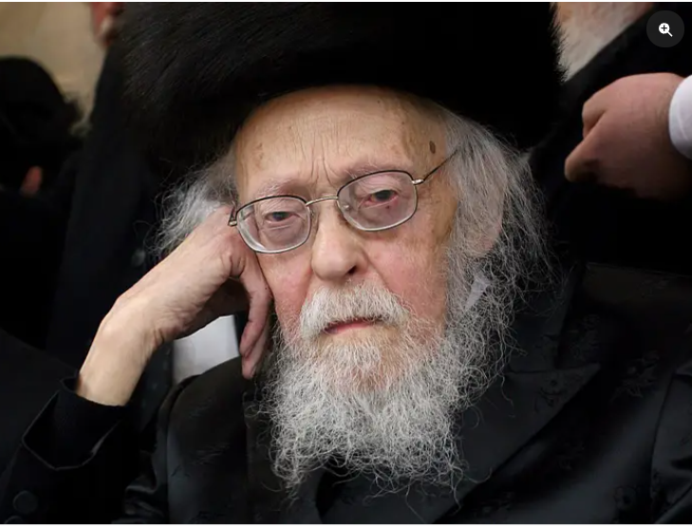

During the summer of 2004, a vein in the heart of HaGaon Rav Yosef Shalom Elyashiv zt”l burst, and the 94-year old Posek Hador was rushed to the hospital in critical condition.
The doctors said there were two options: If they operated on the elderly Tzaddik, the chance of success was only three percent. However, if the surgery was not performed, he would live no longer than three days. The decision had to be made right then and there, on Shabbos.
The Rav’s relatives quickly traveled to his son-in-law, R’ Chaim Kanievsky shlit’a, in Bnei Brak, to get his psak on the matter, and he ruled that in the meantime, nothing should be done.
On Motzei Shabbos, they found out about a specialist from the United States who could take care of the matter without anesthesia and surgery, greatly reducing the risk. The doctor, together with all his instruments, was flown to Israel and, miraculously, the treatment was successful.
For a few weeks it was touch-and-go, but Rav Elyashiv soon made a full recovery and went back to his rigorous learning schedule. Everyone could see that Hashem had answered the prayers of hundreds of thousands of Yidden who had davened for Rav Elyashiv’s recovery.

Another Story was Taking Place Behind the Scenes
But there was another story that took place behind the scenes. It was recounted by R’ Yitzchok Zilberstein shlit’a, Rav of Ramat Elchanan and another son-in-law of Rav Elyashiv. As the entire Jewish world was steeped in prayer on behalf of R’ Elyashiv, a man called the home of R’ Zilberstein in Ramat Elchanan, asking to speak with the Rov.
When the Rav answered the phone, the man on the other line identified himself as a relative of one of the leading Chassidishe Rebbes of the generation. It seems that a number of years back, the Rebbe, a leader and guide to thousands of devoted followers, took ill with mysterious symptoms. Always an active person who saw hundreds of chassidim daily, his body and strength seemed to have shut down. He was unable to fulfill his normal rigorous schedule of Torah, Tefillah and seeing to the needs of his chassidim, and this worried the multitudes; they felt lost without their leader. Top doctors across the spectrum were brought in to determine the cause of the mystery malady, but no one seemed to have the answer.

A Solution Offered by the Manchester Rosh Yeshiva
“It was then that I remembered reading something written by the great Manchester Rosh Yeshiva, R’ Yehudah Zev Segal zt”l,” said the impassioned chasid to R’ Zilberstein. “He wrote that he had never seen even one family that learned Hilchos Lashon Hara earnestly, that did not experience some sort of salvation and solution to an ongoing crisis. I decided right then and there, that on behalf of the health and welfare of our Rebbe, I would organize a learning program, based on the calendar of HaRav Segal whereby we would learn two halachos of Sefer Chofetz Chaim each day.
“It was not hard to attract support for my idea and in a short time, we had a large group of chassidim dedicating their learning of two halachos a day to a refuah shelaima for the Rebbe.”

The Man on the Other Line Became Excited
The man became excited on the other line and exclaimed, “And you know what? It worked! Within a short period of time, the Rebbe had a refuah shelaima and is now back to his usual schedule, learning, davening and seeing to his followers and leading his chassidim, as he did in the past.”
The chasid’s tone suddenly took on a serious note. “I was just thinking that perhaps you might try the same thing on behalf of your father-in-law, the great Rav, and B’ezras Hashem, we will all see his imminent recovery very soon.”
R’ Zilberstein thought it was a wonderful idea and quickly organized the members of Kollel Bais Dovid to begin learning two halachos of Sefer Chofetz Chaim each day. Word got around and many other people joined in the effort, as well. It was then the beginning of Elul and the agreed upon length of their trial was Yom Kippur. A great zeal and exuberance was embraced in this mass effort and everyone fulfilled their allotment of two halachos each day. Even a local seminary in Bnei Brak decided to get in on the act and hundreds of seminary girls accepted upon themselves to learn two halachos a day based on the calendar of the Manchester Rosh Yeshivah, on behalf of the Posek Hador.

Simcha and Joy was Felt
Throughout the Jewish World
Boruch Hashem, simcha and joy was felt throughout the Jewish world when in a short period of time, the news was received that Maran HaGaon R’ Yosef Sholom Elyashiv, was feeling better and his health was restored.

Reprinted from the Parshas Vayeira 5782 email of Rabbi Dovid Hoffman’s Torah Tavlin.

Mitzvah Tank Awakens
Priest’s Jewish Spark
Hidden For 90 Years

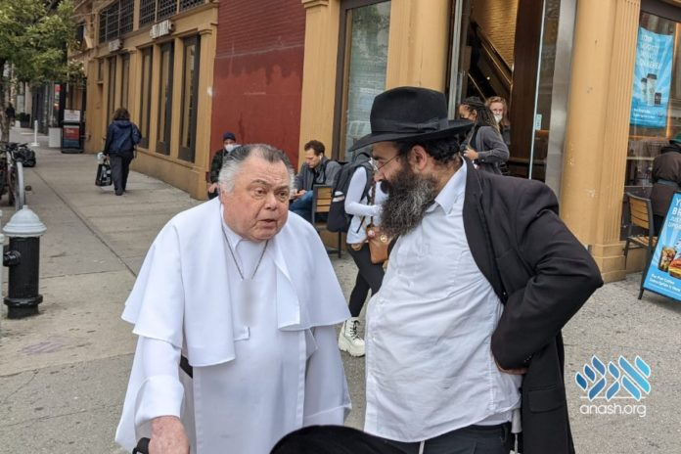

It started as a regular trip on mivtzoyim in Union Square in Manhattan, but ended with discovering a neshama that had been lost among other nations for nearly a lifetime, but still sought connection to her people.
Rabbi Yosef Kratz, caretaker of 770, and Rabbi Yehuda Pevzner, Crown Heights Mivtza Tank coordinator, parked their Mitzva Tank at a busy intersection and began their usual routine of asking passers-by if they were Jewish and if they would like to do a mitzvah.
Then an elderly man approached, and things started getting interesting.
“The truth is that when we asked him if he was Jewish, we were sort of joking. Why would we ask a priest, dressed in long flowing white robes, with a huge cross dangling across his chest, if he was Jewish?” Rabbi Kratz told Anash.org.
But he replied in the affirmative.
“What do you mean? Was your mother Jewish?”

Both His Parents Were Jewish
He answered, “Both my parents were Jews.”
The elderly man explained that as a child, his parents handed him over to a church to survive the Nazi onslaught, and he survived the Holocaust living in the church. Following the war, he began studying to be a pastor r”l. In his school, he was constantly bullied and when he complained to his teacher, a pastor who was also born a Jew, the teacher told him that a Jew will always be persecuted…until he becomes a successful pastor. Which he did. He lived in Pakistan and was a priest there until 15 years ago when he moved to New York.
“Why don’t you come to synagogue?” Rabbi Kratz asked the man.
He wasn’t sure, “Is a priest allowed to come?”
“I work for the Lubavitcher central synagogue in Crown Heights, and I invite you to come.”

The Priest Asked for the Rabbi’s Business Card
He asked for a business card, and said he would keep in touch. Seeing he needed help, the two Lubavitchers helped him get a cab and gave him a chair to sit on until the taxi arrived. After all, the man is an almost 90-year-old Jew…
“I talked to him about speaking to people about the Holocaust. He demurred, saying that we have to pray that it will never happen again. I encouraged him to speak to the young people about it, thus ensuring that it won’t happen again,” Rabbi Kratz said.
Before leaving, the elderly man, who until recently had no visible connection to Yiddishkeit, said he would stay in touch, and try to visit 770. “Make sure to prepare some gefilte fish and kugel for me,” he told them. “Or at least some chopped liver.”
Even after decades of living as a priest in foreign lands, his Jewish spark was not extinguished. It flickered deep inside and a short encounter with a fellow Jew caused it to burst aflame.

Reprinted from the October 14, 2021 website of Matzav.com which reprinted the story from the Chabad website Anash.org

